**Report about conducted load test**

**Date:** 1st of June 2022

**Author:** Oleksandr Maksymenko

**Application:** BlogEngine.NET version 3.2

**Environment:** Host machine where script was run + Virtual Machine where blog is deployed

**Test Environment configuration(RAM, CPU etc.):**

|  |  |
| --- | --- |
| **RAM** | 4096 MB |
| **CPU** | 1 Core CPU (Intel(R) Core(TM) i7-8665U CPU @ 1.90GHz 2.11 GHz) |
| **System Type** | Windows 10 64-bit |

1. **Why such testing was conducted:** To check system’s behavior for specific Admin actions.
2. **Test script description:** Script contains actions for Admin flow. Firstly “user” opens Home page, Logs In, after that starts loop which executes 10 times: Open Admin Page -> Open Users Page -> depending on current number of users -> Create User OR Delete User. After loop ends “user” will be logged off.

1. **Tests:** 2 test runs.  
     
   **Test run preconditions:**

* 2 Admin users
* CSV file with user credentials
* Warmup actions before each test run (Log In, navigate through Blog pages, open Admin page, delete all users by pattern “User_”, Log Out)

**Load Model:**

|  |  |
| --- | --- |
| **Users** | 2 |
| **Rump up time (s)** | 30 |
| **Duration (s)** | 600 |

1. **Short summary on conducted tests:**

* In both test executions we can observe response time was stable and not growing during run.
* Expected load was created for each of 2 users (1 opening of Main Page, 1 Log In, 10 openings of Admin Page, Create User + Delete User in sum gave 10 transactions per user).
* No Server errors were observed during both tests.

1. **Detailed test results:**

**5.1)** Started from Jmeter in GUI mode

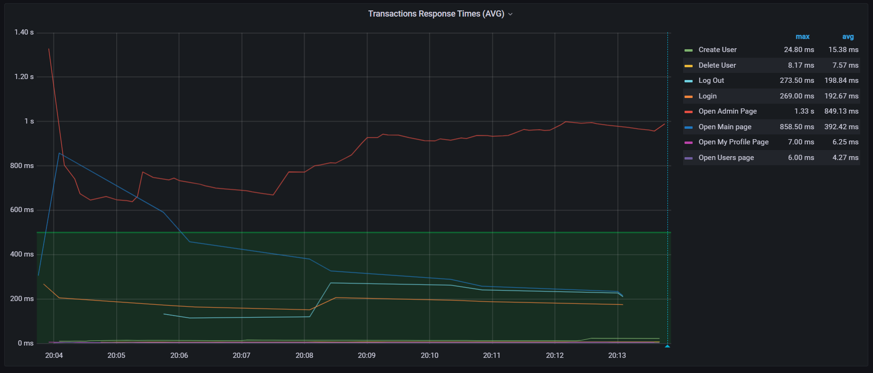

Server’s metrics:

**5.2)** Started from non-GUI mode Jmeter

Server’s metrics:

1. **Conclusion:**

* System handles with 2 concurrent Admin users, response time was not growing, throughput was stable during executions.
* CPU did not reach 100% load during executions, but some “spike” behavior can be observed during both runs, highest peak was 85% in first test and 100% in second run, but in average those spikes were from 40 to 60 %. That behavior can not be seen on graphs before or after test executions, so we can say application was causing these spikes.
* Longest response time was for Open Admin Page (750-850 ms in AVG)